Heavy Rainfall Event in Puerto Princesa City: Insights from Ground Observations, Satellite-derived Precipitation Estimates, and ERA5
Contributed by Daniel James E. Villamil and Sheilla Mae R. Reyes
Philippine Atmospheric, Geophysical and Astronomical Services Administration (PAGASA)

Introduction
Heavy rainfall events (HREs) in the Philippines are frequently associated with various synoptic and mesoscale systems, including tropical cyclones, monsoon surges, and localized convective activity. On 09 February 2025, an episode of heavy rainfall occurred in Puerto Princesa City in Palawan. Public services were disrupted, and many families were displaced due to severe flooding caused by the heavy rain.
This study utilizes a multi-source approach to assess the HRE. By using ground-based observations, precipitation estimates from Integrated Multi-satellite Retrievals for GPM (IMERG) v07 final run, and fifth reanalysis of the European Center for Medium-Range Weather Forecasts (ERA5) data, the analysis provides a more comprehensive understanding of the event’s spatiotemporal characteristics and the associated synoptic environment.
The 24-hour accumulated rainfall recorded by the synoptic station in Puerto Princesa City on 09 February 2025 reached 352.0 mm, exceeding the 30-year climatological normal of 30.7 mm by more than elevenfold. This amount also surpasses the region’s highest monthly climatological normal of 212.9 mm observed in October, the climatologically wettest month. The magnitude of this rainfall anomaly highlights the exceptional nature of the event and underscores its significant meteorological and hydrological impact.
Characterization and Spatiotemporal Assessment of the Rainfall Event
The spatial distribution of 24-hour accumulated rainfall on 09 February 2025, derived from the IMERG data (Fig. 1a), shows two regions exceeding 100 mm: (1) extending from Eastern Visayas to northeastern Mindanao and (2) central Palawan. These regions correspond well with the general spatial pattern observed at PAGASA’s synoptic stations (Fig. 1b). While IMERG effectively captured the general spatial extent of the rainfall, it tends to underestimate regions of high rainfall intensity. In Fig. 1c, IMERG rainfall estimates underestimated most of the accumulated rainfall observed in synoptic stations in Eastern Visayas and Puerto Princesa City. This reflects a known limitation of satellite-derived precipitation products, which often display biases that overestimate (underestimate) relatively weak (strong) rainfall signals (insert reference). In this case, IMERG observed an accumulated rainfall of 300 to 400 mm over central Palawan; however, the location of this rainfall amount is displaced southward relative to the synoptic station in Puerto Princesa City, indicating a spatial mismatch in the satellite retrieval.
The 3-hourly accumulated rainfall comparison between IMERG and synoptic observations (Fig. 2) in Puerto Princesa City indicates that IMERG successfully captured the general timing of the primary rainfall peaks on 08 and 09 February. However, significant discrepancies in magnitude are observed. IMERG overestimated rainfall during the initial peak on 08 February but significantly underestimated the more intense peak on 09 February, during which observed rainfall exceeded 150 mm within a 3-hour period. Additionally, IMERG failed to capture the timing of a third rainfall peak recorded later on 09 February between 18 and 21 UTC.
This study also evaluated the model performance of PAGASA-WRF’s 3-kilometer resolution configuration. Three different model initializations (12 UTC, 18 UTC of 08 February and 00 UTC February 9) were used to analyze 24-hour and 3-hour accumulated rainfall for 09 February. PAGASA WRF’s rainfall spatial distribution over the two regions previously discussed were generally consistent across all initializations with slight variations in intensity. The concentration of intense rainfall projections over Palawan were displaced south of Puerto Princesa, indicating a spatial mismatch of PAGASA-WRF’s accumulated rainfall, similar to IMERG’s retrieval.
PAGASA-WRF’s 3-hourly accumulated rainfall over Puerto Princesa station was also compared alongside IMERG and synoptic observation data (Fig.2). All initializations underestimated the heavy rainfall event on 09 February, along with the 150 mm-peak. The 12 UTC initialization captured the timing of the peak but the intensity was grossly underestimated.
Progression of Synoptic-Scale Features
In this study, three atmospheric variables from ERA5 were used to discuss the synoptic systems governing the HRE: 10-m zonal and meridional winds, mean sea level pressure (MSLP), and total column water vapor (TCWV). The anomaly fields (Fig. 3) were computed relative to the 1991-2020 November to March (NDJFM) mean. The temporal evolution was examined from Day -5 to Day + 1, with 09 February 2025 designated as Day 0.
On Day -5 (04 February), no significant rainfall was recorded in the Philippine landmass; most of the precipitation was mainly offshore. A negative MSLP anomaly was evident over northern Japan, while TCWV anomalies indicated dry conditions across the Philippine region. By Day -4 (05 February), the anomalous low over Japan began to move northeastward, and the Siberian High was starting to strengthen as indicated by positive MSLP anomalies. Moisture transport into the southern Philippines increased, coinciding with the rainfall along Eastern Visayas and eastern Mindanao.
Day -3 (06 February) marked a critical transition toward a favorable environment, setting the stage for the impending HRE. The 24-hour accumulated rainfall map showed a notable increase in precipitation over the central Philippines, particularly across Visayas. Rainfall amounts over this region exceed 100 mm. In Siberia, the positive anomaly strengthened, resulting in a higher east-west pressure difference. One notable observation on this day was the confluence of the northeasterly winds and southeasterly winds over east of 128°E and south of 15°N, which also coincides with a significant increase in moisture content over the area.
On Day -2 (07 February), positive anomalies associated with the intense Siberian High began to propagate southward, enhancing the north-south pressure gradient and triggering a northeasterly surge west of the Philippines. Concurrently, an anomalous low developed over Palawan. A two-day lag was observed between the onset of the Siberian High intensification and the resulting surge over the South China Sea. This surge continued to intensify, reaching its peak on 09 February. During this three-day period, Puerto Princesa City experienced a record-breaking rainfall accumulation, primarily driven by the anomalous low over the region and the sustained moisture influx from the northeasterly surge.
On Day 0, (09 February), the Siberian High began to weaken while the anomalous low near Borneo was more pronounced, indicating a deepening low-level disturbance. The 24-hour accumulated rainfall was the highest over Palawan on this day. The positive TCWV anomalies (high moisture) and low-level convergence associated with the disturbance provided a highly favorable environment for sustained convection.
In the post-event period (Day + 1, 10 February), the MSLP anomaly over mainland China became negative, indicating a weakening Siberian High. The anomalous low began to move northwestward away from Palawan, along with its convection and strong positive TCWV anomaly. A significant reduction in rainfall over Palawan was then observed.
Synthesis and forecasting implications
This case highlights the importance of integrating satellite-derived estimates, ground observations, and reanalysis data to capture the evolution of high-impact weather events. The HRE in Puerto Princesa City on 09 February 2025 was the result of a complex interaction between large-scale synoptic features and local moisture dynamics. The evolution of a strong northeasterly surge associated with the intensified Siberian High, the development of an anomalous low over Palawan, and enhanced moisture transport created an environment highly favorable for sustained convective rainfall. Improved monitoring of these large-scale features is crucial for anticipating similar events in data-sparse regions, such as Palawan.

Reference
- Progress Report No. 1 for the Effects of Shear Line in MIMAROPA (https://ndrrmc.gov.ph/attachments/article/4281/Progress_Report_No_1_for_the_Effects_of_Shear_Line_in_MIMAROPA.pdf)

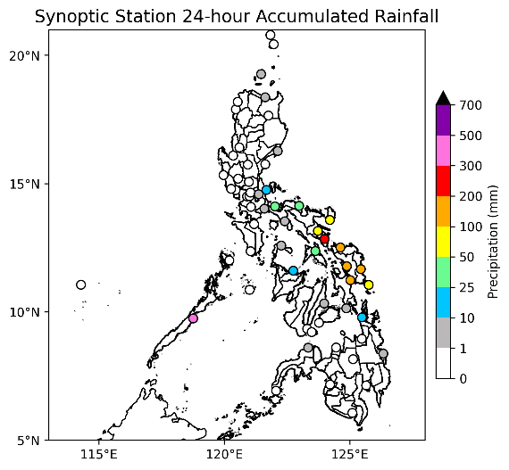
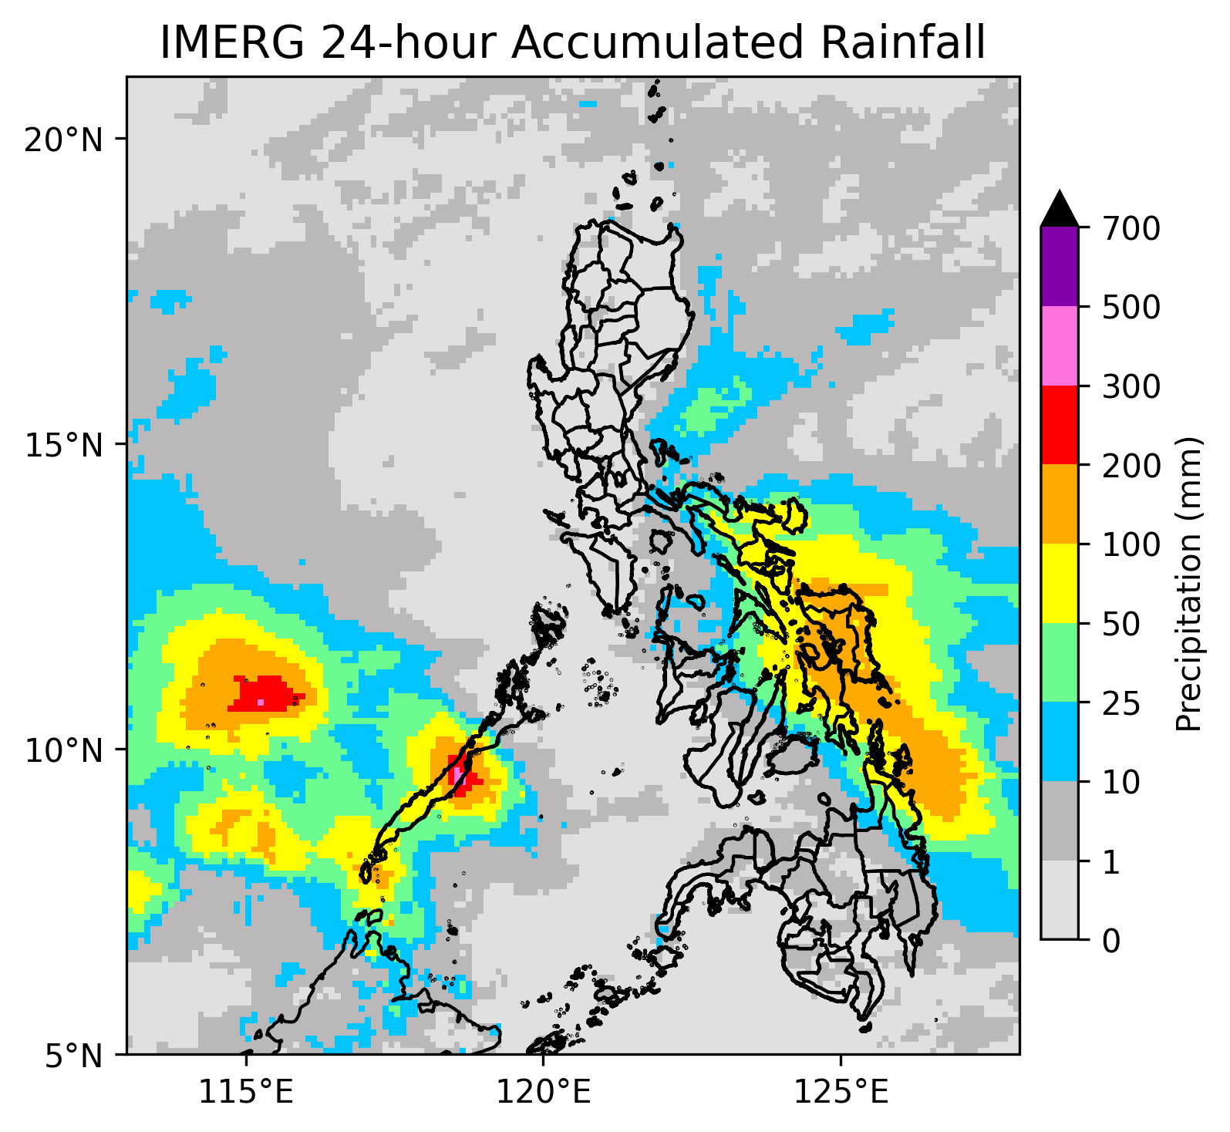
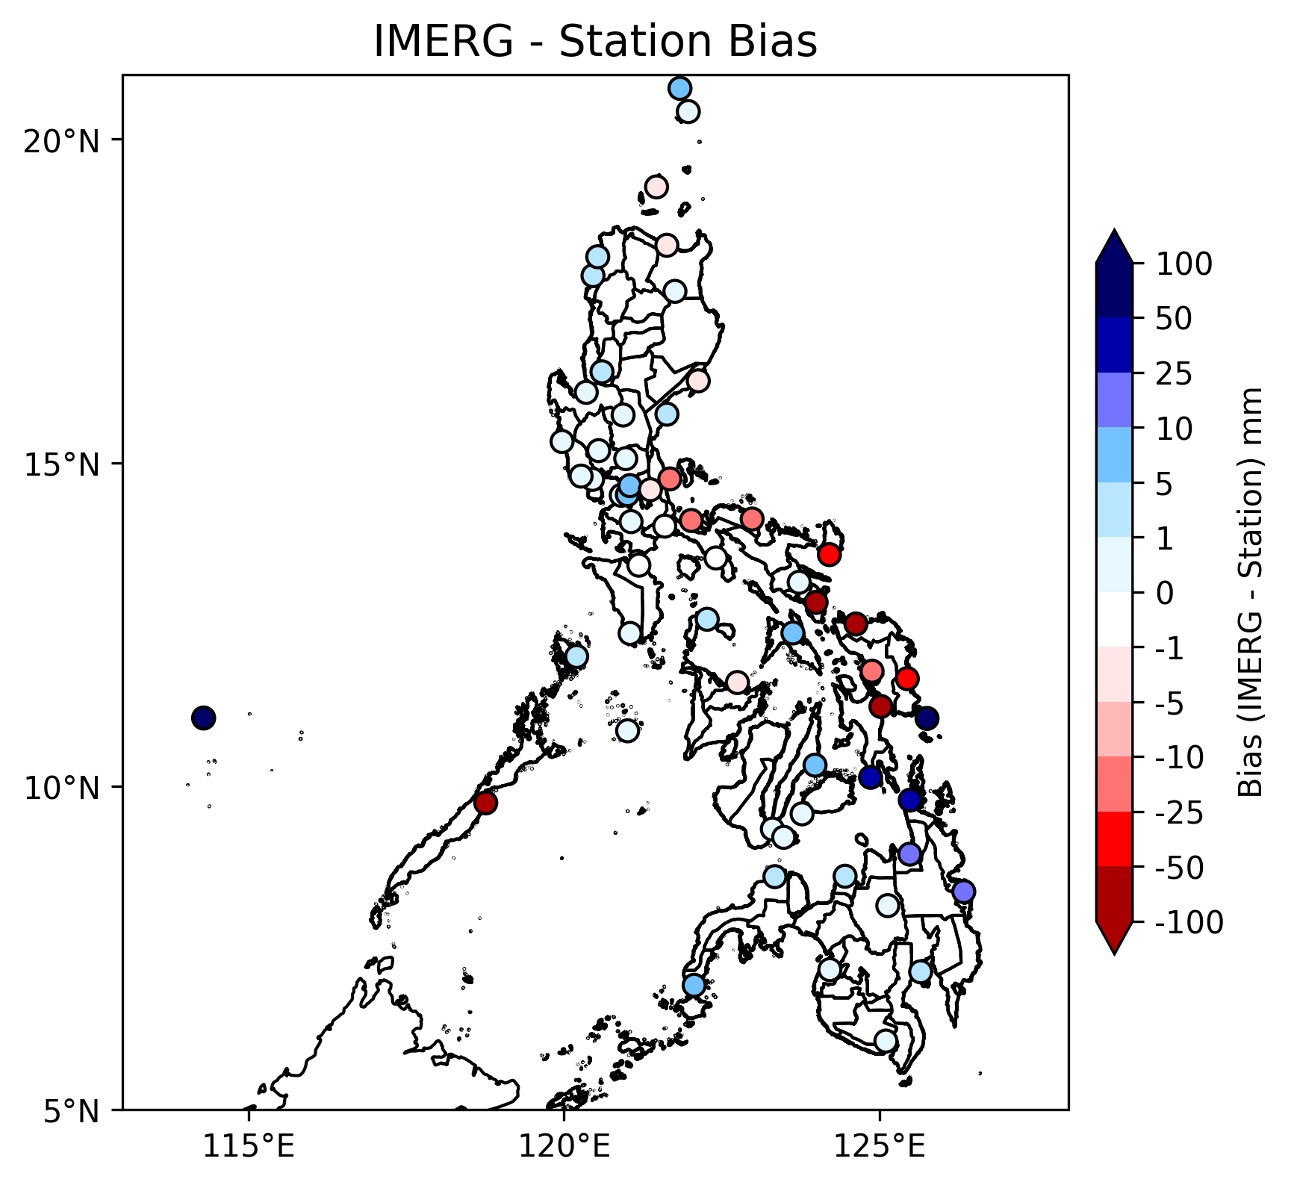

Fig. 1. Comparison of 24-hour accumulated rainfall on 09 February 2025: (top) from IMERG, (middle) PAGASA’s synoptic weather stations, and (bottom) the resulting bias between IMERG and synoptic station observations.

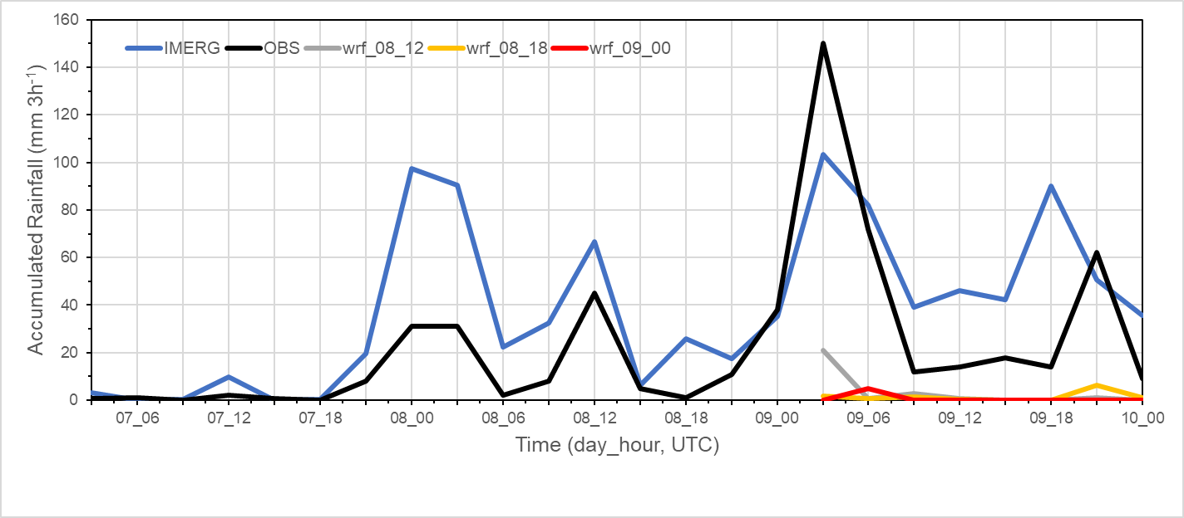
Fig.2. Time series of 3-hourly accumulated rainfall from 00 UT 07 February to 00 UTC 10 February 2025, comparing precipitation estimates from IMERG (blue), rainfall observations from synoptic (black) in Puerto Princesa City, and 09 February 2025 accumulated rainfall from PAGASA-WRF 3 km (12 UTC, 18 UTC 08 February 2025, and 00 UTC 09 February 2025 initial runs).

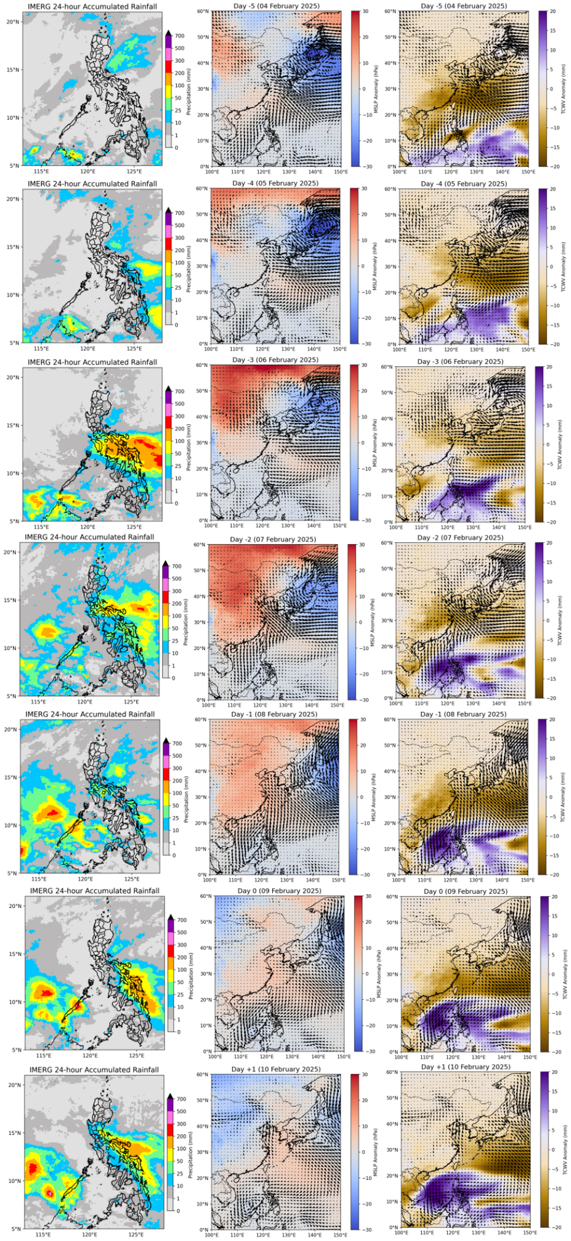
Fig. 3. Daily progression of rainfall and large-scale synoptic environment from Day -5 (04 February 2025) to Day +1 (10 February 2025) during the heavy rainfall event in Puerto Princesa City. The first column shows IMERG 24-hour accumulated rainfall. The second column presents the daily mean ERA5 mean sea level pressure (MSLP; shaded, hPa) anomalies with 10-m horizontal wind anomaly vectors. The third column is the daily mean ERA5 total column water vapor (TCWV; shaded, mm) overlaid with 10-m horizontal wind anomaly vectors. All anomalies are relative to the NDJFM 1991-2020 mean.

